Good Friday Family Service

A Children’s Morning Prayer Liturgy
April 15, 2022 | 10:00am

This Liturgy is adapted from the Book of Alternative Services and adapted for Children

10:00am Family Service

Gathering of the Community | Morning Prayer

Presider Creator God, open us up,
All And we will shout your praise

Presider O God, be quick to be with us.
All O God, be quick to help us.

All Glory to the Creator, Sustainer, & Reedemer:
as it was in the beginning, is now,
and will be for ever. Amen.

The Invitatory

Presider Once there was someone
who said such amazing things
and did such wonderful things
that people began to follow him.
But they didn’t know who he was.
So one day they asked him, and he said:
All I am the Light!

A Candle is lit

An Action Psalm
(Adapted from Psalm 24, join in the actions that are underlined)

Leader The earth is God’s and all that is in it,
All *the world and all who live upon it.

Leader For it is God who created it upon the seas
All *and made it firm on the rivers of the deep.

Leader Who can climb the hill of God?
All *and who can stand in this holy place?

Leader Lift up your heads,
break down the walls and open your doors;
All *and the Creator of All shall come in.

Leader Who is this Creator of All?
All *The Lord of heaven and earth,
the King of glory.

Leader Creator and ruler of all, open our hearts that the King of glory may enter, and bring us singing to your holy mountain, where you live and reign, now and for ever.

A Story
The Mystery Of Easter

Creative Work
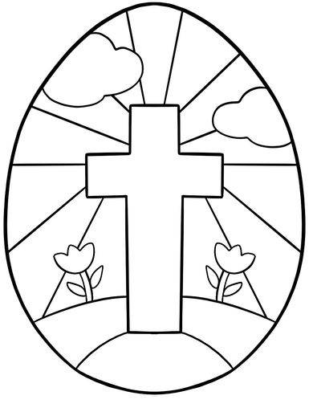
Wander around the space and interact with the prayer stations
and activities, make sure you help with building the Easter Garden
and create some peg people!

The Lord’s Prayer

Presider As our Saviour taught us, let us pray,
All Our Father in heaven,
hallowed be your name,
your kingdom come,
your will be done,
on earth as in heaven.
Give us today our daily bread.
Forgive us our sins
as we forgive those who sin against us.
Save us from the time of trial,
and deliver us from evil.
For the kingdom, the power,
and the glory are yours,
now and for ever. Amen.

Presider Let us bless the Lord.
All Thanks be to God.

Activity
How many crosses can you find? Include Captial and lower case letter “T” “t”?_____________

What colours were used the Godly Play story?_______________

How many prayer stations are there?__________________________

What is your favourite part of lent?__________________________________________________________

What is your favourite part of Easter?________________________________________________________

Join us on Easter Sunday to present the Easter Garden to the whole congregation and take part in an Easter Egg Hunt and story!

To donate
Please text “Give” to 639.739.0843 and follow the instructions —
or go to thecathedral.ca/give —or go to the App Store, & choose the “tithe.ly” app
from the App Store, download the app, enter your information
and you can connect directly to the Cathedral —
Thank you for your support!
Presider The Rev. Jessica Schaap
Godly Play Lauren Odile Pinkney

Thank you for joining the Christ Church Cathedral community.
This Choral Eucharist service takes place on the traditional, ancestral, and unceded territory
of the Musqueam, Squamish, and Tsleil-Waututh Nations in the heart of Vancouver.

If you have any questions about the Cathedral, its ministries or congregations, please visit our website at thecathedral.ca.
MAILING ADDRESS: 690 Burrard Street, Vancouver, BC V6C 2L1
PHONE: 604.682.3848 | EMAIL: reception@thecathedral.ca

